39.57: a) The maxima occur when 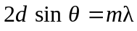 as described in Section 38.7.
b) 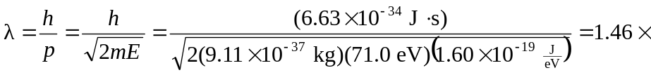
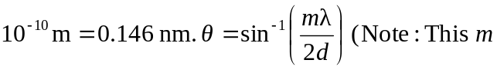 is the order of the maximum, not the mass.)
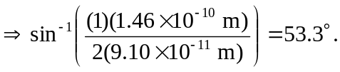
c) The work function of the metal acts like an attractive potential increasing the kinetic energy of incoming electrons by 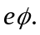 An increase in kinetic energy is an increase in momentum that leads to a smaller wavelength. A smaller wavelength gives a smaller angle (see part (b)).

